Drug Guardian

Blockchain in Drug Supply Chain Protection

Tanishka Jayesh Das

Department of Computer Engineering

Vidyavardhini’s College of Engineering and Technology Vasai, India

[tanishka.221513201@vcet.edu.in](mailto:tanishka.221513201@vcet.edu.in)

Pallavi Rajendra Dhandar

Department of Computer Engineering

Vidyavardhini’s College of Engineering and Technology Vasai, India

[pallavi.221583202@vcet.edu.in](mailto:pallavi.221583202@vcet.edu.in)

Jatush Vasantrai Hingu

Department of Computer Engineering

Vidyavardhini’s College of Engineering and Technology Vasai, India

[jatush.221723101@vcet.edu.in](mailto:jatush.221723101@vcet.edu.in)

Akash Rajapandian Nadar

Department of Computer Engineering

Vidyavardhini’s College of Engineering and Technology Vasai, India

[akash.222173101@vcet.edu.in](mailto:akash.222173101@vcet.edu.in)

Prof. Brinal Colaco

Guide

Third Year Engineering

Vidyavardhini’s College of Engineering and Technology Vasai, India

***Abstract* — This study presents a blockchain-based solution for tracking the pharmaceutical drug supply chain, aimed at enhancing transparency, security, and authenticity from the production stage to the final sale. Utilizing Ganache for blockchain simulation and MetaMask for account management, we create a decentralized ledger that immutably records each transaction in the drug's lifecycle. From the sourcing of raw materials to manufacturing, distribution, and retail, every stage is tracked, allowing authorized participants to update and monitor the drug's movement in real time. Smart contracts automate the verification process, ensuring that predefined conditions are met at each stage of the supply chain. This system not only ensures the integrity of the supply chain but also provides a reliable audit trail for regulatory authorities, reducing the risk of counterfeit drugs. End users, such as consumers and pharmacies, benefit from the ability to verify the authenticity and safety of the drugs they purchase, contributing to a more secure and trustworthy pharmaceutical ecosystem.**

***Keywords —*** *Blockchain, Pharmaceutical supply chain, Transparency, Security, Authenticity, Ganache, MetaMask, Decentralized ledger, Immutability, Real-time tracking, Smart contracts, Verification process, Drug lifecycle, Supply chain integrity, Regulatory compliance, Counterfeit prevention, Audit trail, Consumer safety, Drug authenticity, Decentralized system.*

1. **INTRODUCTION**

The pharmaceutical industry faces critical challenges in maintaining the integrity, safety, and authenticity of drugs throughout the supply chain. Counterfeit medications, mishandling, and lack of transparency can lead to compromised products, posing significant risks to patients' health. Traditional supply chain systems struggle to provide the level of transparency and traceability needed to ensure drug safety from the point of manufacture to the end user. This project proposes a blockchain-based solution to address these issues by creating a transparent, decentralized, and immutable ledger that tracks every transaction in the drug supply chain, ensuring data integrity and accountability at every stage. Our blockchain system begins tracking the drug from the raw material stage, through manufacturing, distribution, and retail, until the final sale. Each stakeholder, from producers to retailers, has a clear, real- time view of the drug's location and status in the supply chain, ensuring complete visibility. By using Ganache for blockchain simulation and MetaMask for account management, we simulate the creation of multiple accounts for stakeholders, allowing seamless transactions between them. Smart contracts play a critical role in this system, automatically verifying that each condition in the supply chain is met before progressing to the next stage,

reducing human error and enforcing secure and timely transfers. This blockchain-based approach not only ensures greater transparency and traceability but also addresses regulatory compliance and provides an immutable audit trail for health authorities. By securing the entire lifecycle of the drug, from raw materials to the final product on the shelf, it drastically reduces the risk of counterfeit drugs entering the supply chain. The system empowers stakeholders with real-time data and gives end consumers the ability to verify the authenticity and safety of the drugs they purchase, thus enhancing trust and security in the pharmaceutical industry. Ultimately, this solution fosters a safer, more reliable, and efficient pharmaceutical supply chain.

1. **PROBLEM DEFINITION**

The current methods for tracking pharmaceuticals

1. **PROPOSED APPROACH**

Embarking to Develop a Secure Access Mechanism: Implement a verification system using college student IDs to ensure that only authorized students from specific campuses can access the application. This will enhance security and prevent unauthorized access to sensitive data.

1. **Implement a Secure Tracking System:** Develop a blockchain-based platform that securely records every transaction in the drug supply chain, ensuring that stakeholders can verify the authenticity and journey of pharmaceuticals from production to sale. This will enhance trust and accountability in the system.
2. **Create a Transparent Supply Chain:** Design a user- friendly interface that allows manufacturers, distributors, and retailers to access real-time information about drug movements, thereby improving visibility and traceability throughout the

within the supply chain are fragmented and lack transparency, leading to significant inefficiencies, heightened risks of counterfeit drugs, and challenges in regulatory compliance. Many stakeholders rely on outdated systems like paper-based documentation or siloed digital platforms, which hinder real-time tracking and data visibility. This fragmentation not only delays communication but also weakens the ability to verify drug authenticity, making it easier for counterfeit or substandard medications to enter the market. Counterfeit drugs pose serious health risks, erode consumer trust, and contribute to major global issues in public health. Furthermore, pharmaceutical companies face mounting pressure to meet stringent regulatory requirements, such as the Drug Supply Chain Security Act (DSCSA) and the Falsified Medicines Directive (FMD), yet current systems

supply chain.

**Testing Facilitate Real Time Updates:** Enable stakeholders to easily update and track the status of drugs at each stage of the supply chain. Implement features that allow for instant notifications and alerts regarding any changes in drug status, such as recalls or transfers.

1. **METHODOLOGY**

The methodology for developing the blockchain-based pharmaceutical supply chain solution encompasses several key phases: planning, design, implementation, testing, deployment, and future enhancements. Below is a detailed outline of the methodology:

struggle to provide the necessary transparency and real- time data required for compliance, leading to costly audits and potential disruptions.

To address these challenges, a blockchain-based solution offers a promising alternative by creating a secure, decentralized, and immutable ledger for tracking pharmaceuticals. Such a system would enable real-time, end-to-end visibility of drugs as they move through the supply chain, ensuring that all stakeholders can verify the authenticity and safety of medications. By fostering collaboration and providing a single source of truth, a blockchain-based platform could reduce the risks of counterfeit drugs, streamline regulatory compliance, and improve overall supply chain efficiency.

1. **Requirement Analysis**: A thorough analysis of the requirements should be conducted, focusing on the needs of key stakeholders such as manufacturers, distributors, retailers, and regulators. This includes understanding technical specifications and ensuring regulatory compliance. The scope of the application should be clearly defined, with specific objectives outlined to guide the development process.
2. **Design Phase:** A high-level architecture and system design for the blockchain solution should be developed, outlining the overall structure, components, and interactions between stakeholders like manufacturers, distributors, retailers, and regulators. The design should include a user-friendly interface (UI) and user experience (UX) to ensure accessibility and visual appeal. The blockchain architecture and smart contract specifications must be defined to enable secure tracking, efficient transaction management, and ensure compliance with regulatory requirements.
3. **Implementation:** The development of the blockchain platform should utilize appropriate programming languages and development frameworks to ensure efficiency and scalability. User authentication and access control mechanisms must be implemented to restrict access to authorized stakeholders only. Features for tracking drug movements should be integrated, including real-time updates, alerts for recalls, and transaction management capabilities. Additionally, a knowledge base should be established within the application to provide users with relevant information and address common queries effectively.
4. **Testing:** Comprehensive testing should be conducted to ensure the functionality, usability, and security of the blockchain solution. This includes performing unit testing to validate individual components and smart contracts. Integration testing should be conducted to verify the seamless interaction between different features and functionalities. User acceptance testing (UAT) must also be executed to gather feedback from real users and validate the solution's effectiveness in meeting their needs.
5. **Deployment:** The application should be prepared for deployment by ensuring it adheres to regulatory guidelines and requirements for pharmaceutical tracking systems. 13 Once ready, the application can be rolled out to stakeholders, facilitating a smooth transition process. This rollout should include providing necessary support and training to ensure all users are comfortable and proficient with the new system.
6. **Monitoring and Maintenance:** Monitor the performance and usage metrics of the blockchain solution post-deployment. Address any issues or bugs identified by users through timely updates and maintenance releases. Continuously collect feedback from stakeholders to identify areas for improvement and ensure the system meets evolving needs.
7. **Future Enhancements:** Explore the integration of advanced technologies, such as machine learning for predictive analytics in supply chain management, and investigate additional features like enhanced reporting tools and data analytics for stakeholders. Continuously evaluate emerging technologies and user needs to adapt and enhance the functionality and features of the blockchain solution over time. By following this methodology, the development team can ensure the successful implementation and continuous improvement of the blockchain-based pharmaceutical supply chain solution, thereby creating a reliable and efficient platform for tracking drugs throughout their journey from production to consumption.

**V. RESULTS**

The implementation architecture of the blockchain-based pharmaceutical supply chain solution comprises several components that work together to provide a secure, efficient, and user-friendly platform for tracking drugs. The architecture follows a modular design, facilitating scalability, maintainability, and future enhancements. Below is a block diagram illustrating the key components and their interactions, along with a flowchart demonstrating the application's workflow:

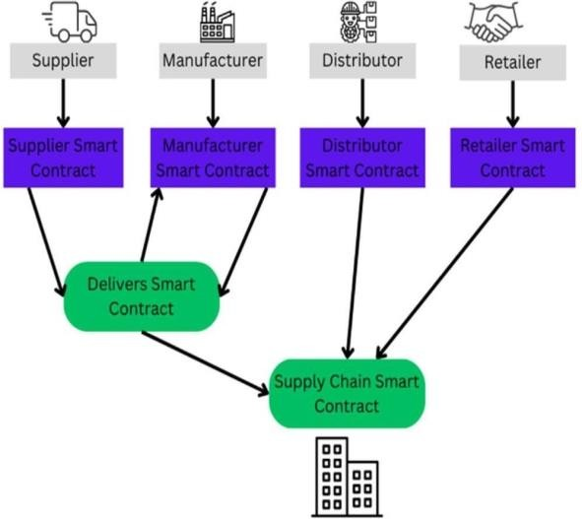

Figure 5.0: Workflow of the site

1. **Implement a Secure Tracking System:** Develop a blockchain-based platform that securely records every transaction in the drug supply chain, ensuring that stakeholders can verify the authenticity and journey of pharmaceuticals from production to sale. This will enhance trust and accountability in the system.
2. **Blockchain Perform:** The core application where users (manufacturers, distributors, retailers, and regulators) interact with the pharmaceutical tracking system.
3. **User Interface (UI) :** Represents the graphical interface through which users navigate the application, view drug tracking information, initiate transactions, and access features like the knowledge base.
4. **User Authentication:** Verifies user credentials, ensuring that only authorized stakeholders can access the system. This includes implementing secure login methods and access control.
5. **Owner Module:** The Owner module in Drug Guardian is essential for managing drug ownership in the supply chain. It allows authorized entities like manufacturers

and distributors to register, authenticate, and transfer drug ownership as products move through the chain.

1. **Distributor Module:** This is specifically designed for wholesalers and distributors who manage drug logistics. It includes tools for order processing, shipment management, inventory tracking, and updating drug status as it moves along the supply chain.
2. **Retailer Module:** This module supports the management of drug inventory and transactions at the retail or pharmacy level. It tracks received drugs, helps verify authenticity, and manages the sale or dispensation of drugs to customers, ensuring safety and transparency.
3. **Blockchain Database:** The drug movements, user profiles, and compliance records. This ensures data integrity and transparency across the supply chain.
4. **Future Enhancements:** Represents potential future improvements to the application, such as integrating machine learning for predictive analytics in supply chain management and exploring additional features for reporting and data analytics.

Following is the flow chart which shows Process design of out app:

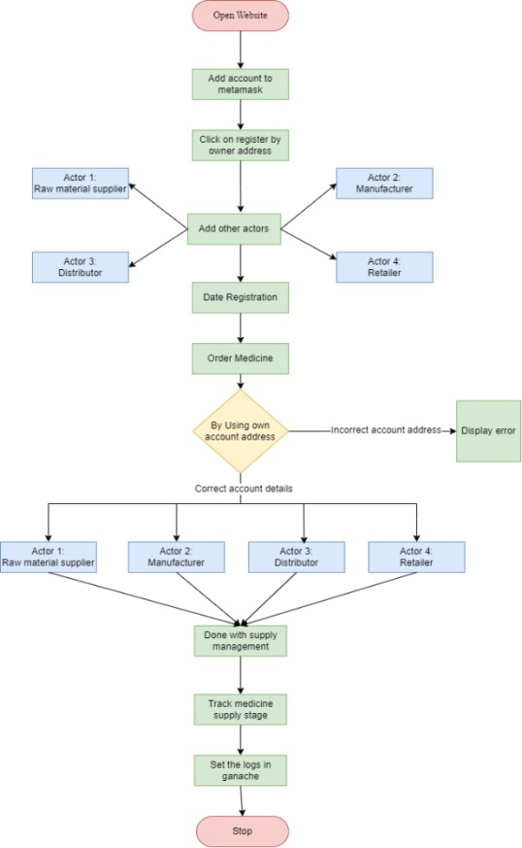

Figure 5.1: Process Diagram of site

# User Enters the App:

* + - The user accesses the app's splash screen

# Check for Existing Account:

* + - If the user already has an account, proceed with login process. - If not, display the register user screen.

# Login Process:

* + - User enters their username/email and password.
    - The system validates the credentials.
    - If valid, redirect to the home screen.
    - If not, display an error message.

# Registration Process:

* + - User clicks on the registration.
    - User provides necessary information (e.g., name, email, password).
    - The system validates the information.
    - If valid, create a new account and redirect to the home screen.
    - If not, display an error message.

# Home Screen:

* + - After successfully logging in or registering, the user is redirected to the home screen.
    - The home screen displays various roles, allowing users to select their specific functions:
      * Raw Produce
      * Manufacturer
      * Distributor
      * Retailer
      * Logout Button

# Tracking Section:

* + - In this section, the user can view a list of drugs along with their tracking information**.**
    - Users can select a specific drug to view its journey through the supply chain, including current status and location.

# Logout:

* + - User can log out from their account by clicking the logout button. - After logout, they are redirected to the login or registration page.

The actual results are shown below:

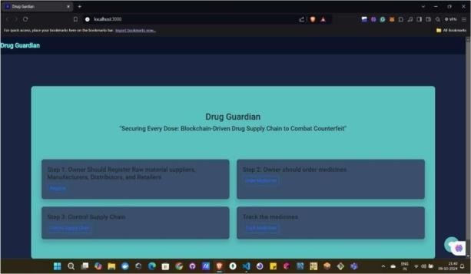

Figure 5.2: Home page interface

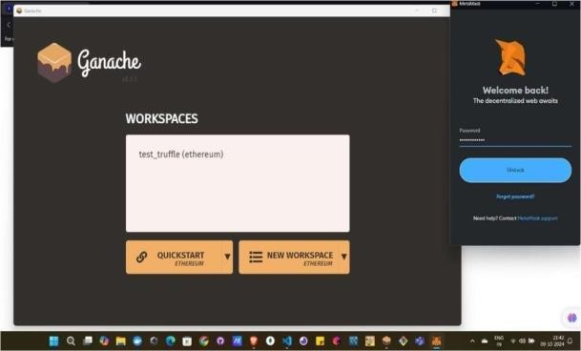 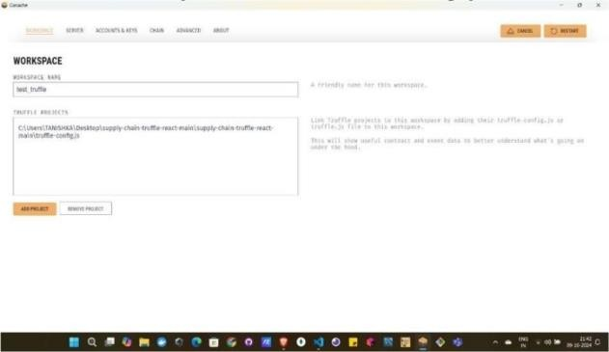

Figure 5.3: Ganache Interface

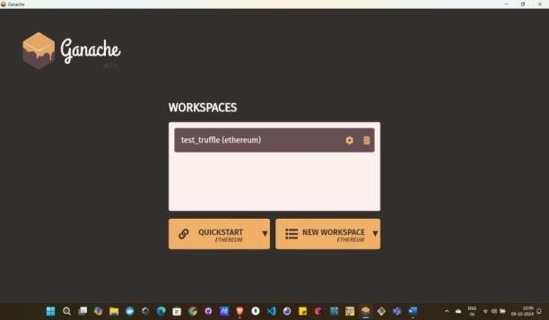

Figure 5.4: Ganache connecting to Metamask

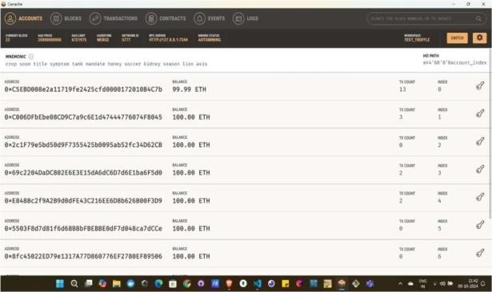

Figure 5.5: Ganache Account details page

Figure 5.6: Ganache Workspace interface

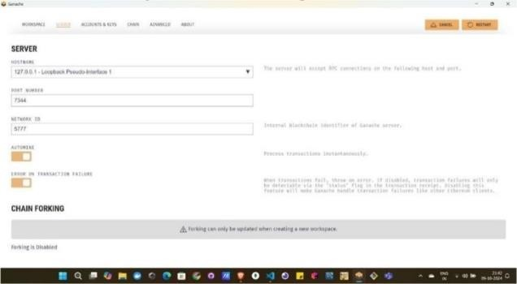

Figure 5.7: Ganache Server

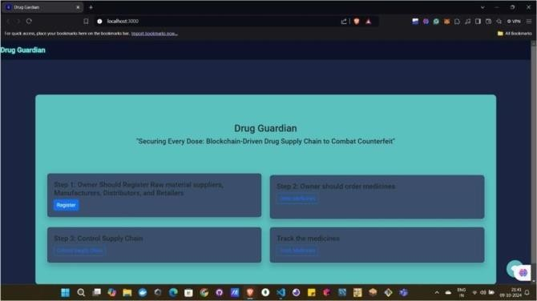

Figure 5.8: Home page

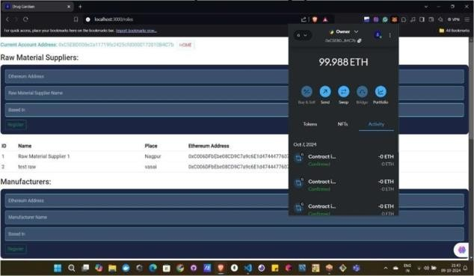 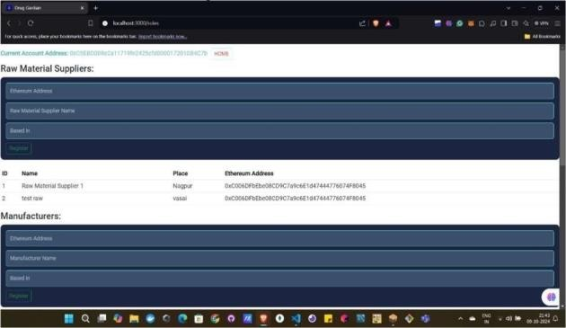

Figure 5.9: Raw material suppliers page

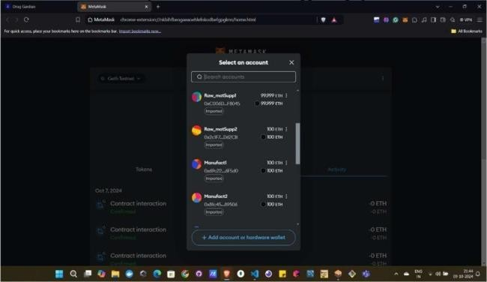

Figure 5.10: Metamask Account of actors

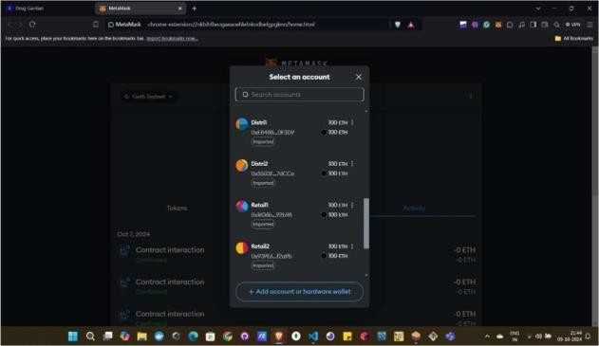

Figure 5.11: Metamask Account

Figure 5.12: Raw Material supplier interface

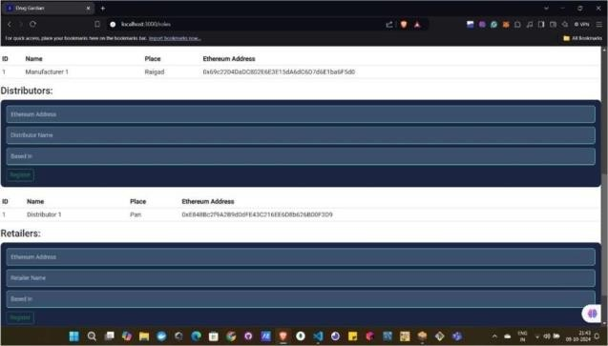

Figure 5.13: Distributors Page

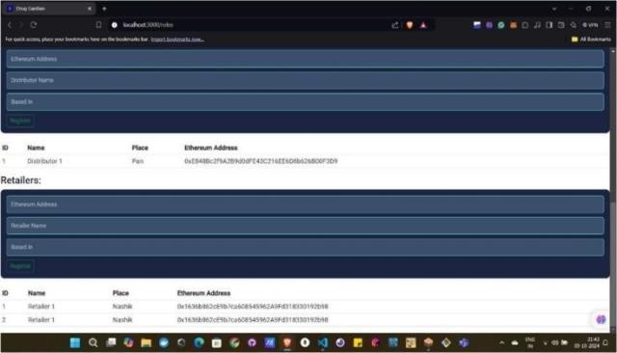

Figure 5.14: Retailers page

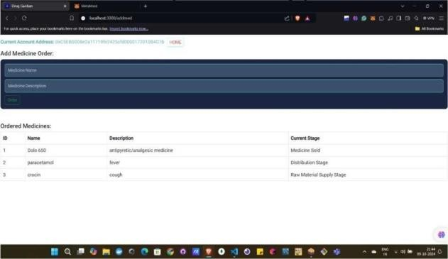 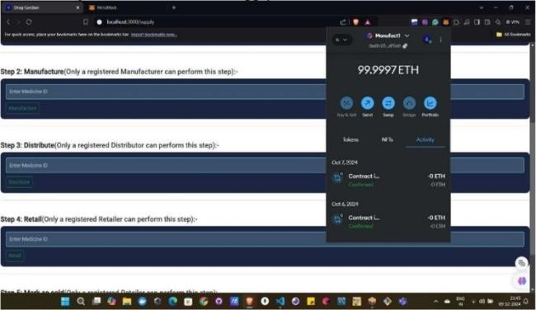

Figure 5.15: Add medicine page

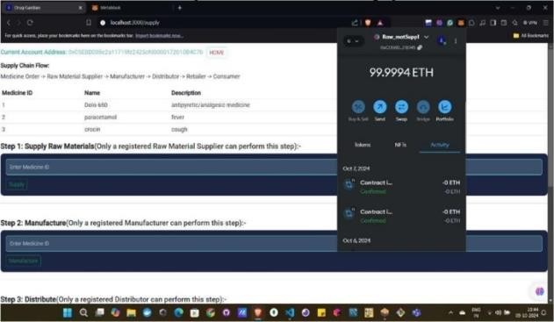

Figure 5.16: Supply flow chain page for raw manufacturer

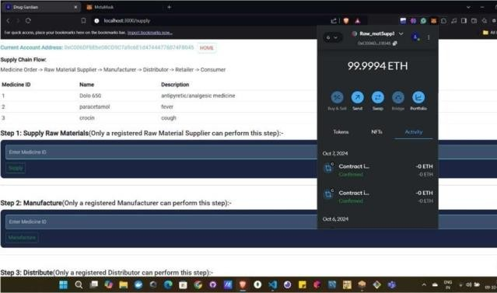

Figure 5.17: interface of supply chain flow for raw manufacturer

Figure 5.18: Interface of supply chain flow for manufacturer

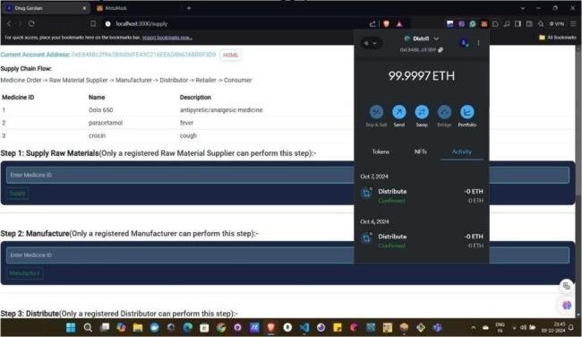

Figure 5.19: Interface of supply chain flow for

Distributer

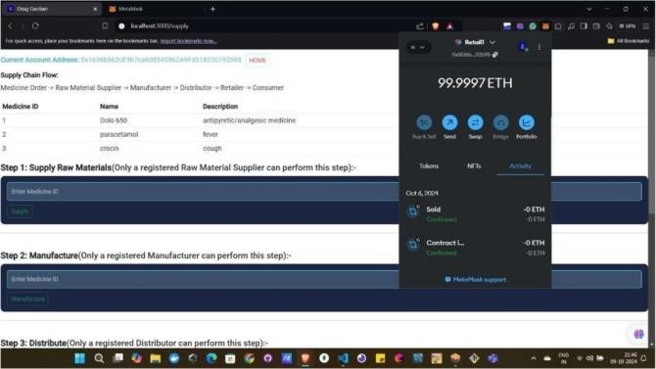

Figure 5.20: Supply chain flow for Retailer

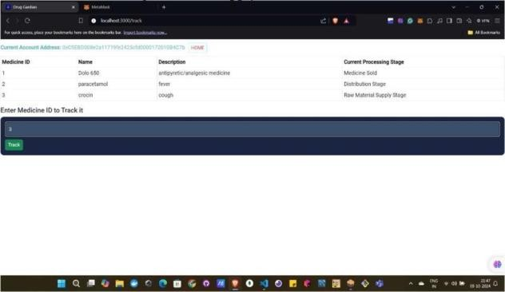

Figure 5.21: Interface for tracking medicine

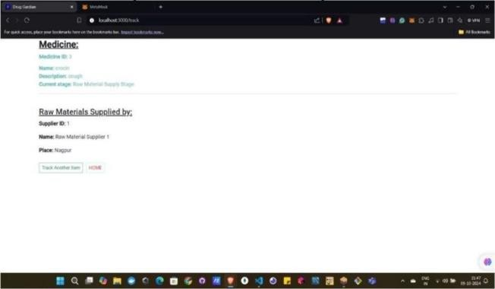

Figure 5.22: Output of a medicine which has been tracked

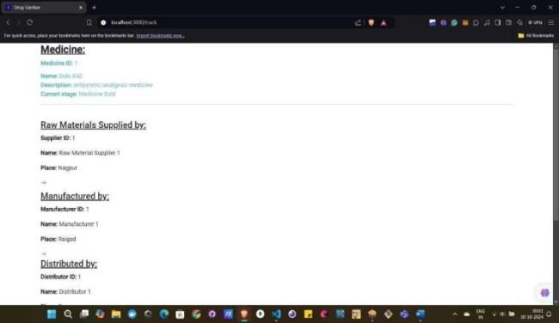

Figure 5.23: Details about medicine and its status

Figure 5.24: Details of the medicine which is sold

# Explanation:

Fig 5.2 shows 1st page of the website. Then before register make connection between metamask and ganache blockchain by starting the workspaces created by you (here test truffle is the workspace created by us) as shown in fig 5.3 enter the password of metamask and start the account. Once ganache started it will show the 10 Ethereum accounts as shown in fig 5.5. By clicking on settings, you can go to this page where you can see the workspace and how the ganache is connected to truffle config.js file by giving the address for same shown in fig

5.6. Here the server is connected to our host and port so the same server should be there in truffle config file too.th. Click on register (here online owner can to this step). The current address is of owner as the owner will only perform the task of adding different actors in metamask. Here you can see the owner has added the actors (i.e. Raw material supplier, manufacturer, distributor and retailer) by importing the accounts from ganache blockchain (Geth test) by using the private key provided by it. Once all required actors are made by owner there address are added one by one in then required filed and registered them with name, place and there ETH address as shown in 5.12. After registering all the actors successfully, now owner can move to add medicine which is required to be made. (This step is also performed only using owner’s account is anyone else try error will be occurred). As shown in 5.15 Once medicine is added then, each actor performs it work by using the accounts created for them. (e.g. “raw material supplier 1” will supply raw material by using its account and add the medicine id for which the supplier is supplying the material). Similarly goes for other actors too. After performing above steps, you can track the medicine by entering the medicine id you want to track. (Note: the tracking step can be performed by any actor as per there need) As shown in 5.21, 5.22. Finaly you can see the status of your medicine in effective way as shown in 5.23.

You can also see the whole project with source code on GitHub:

<https://github.com/tanishka786/Drug_Blockchain.git>

**VI. FRONTIERS FOR FUTURE INNOVATION**

The Drug Guardian platform utilizes blockchain technology to enhance the security, transparency, and efficiency of the drug supply chain. By leveraging decentralized ledgers, the platform ensures that all stakeholders, including manufacturers, distributors, pharmacies, and patients, have access to accurate and real- time information regarding drug provenance and authenticity. This approach not only minimizes the risk of counterfeit drugs entering the market but also fosters trust among users. The platform's design addresses critical challenges within the pharmaceutical industry, such as traceability, regulatory compliance, and data integrity. Through continuous development, Drug Guardian aims to transform the drug supply chain, contributing to better healthcare outcomes and patient safety.

Enhancing Interoperability with Existing Systems: Future efforts will focus on ensuring that the Drug Guardian platform can seamlessly integrate with existing healthcare systems, including electronic health records (EHR) and pharmacy management systems. This will improve data flow and collaboration among stakeholders. By pursuing these initiatives, the Drug Guardian platform will continue to evolve as a comprehensive solution for ensuring the integrity and safety of the drug supply chain, ultimately benefiting patients and healthcare providers alike.

**ACKNOWLEDGMENT**

We would like to express our special thanks and gratitude to Our Institute, **Vidyavardhini’s College of Engineering and Technology**, our principal **Dr. Rakesh Himte**, Our Head of Department **Dr. Megha Trivedi** and our Project Guide **Mrs. Brinal Colaco** who gave us this valuable opportunity to develop this major project on the topic: Drug Supply Chain: This website helps make sure that medicines are safe by tracking them from the time they are made to when they are sold in the store. We use a special system called blockchain to keep everything recorded. It shows every step, like where the ingredients come from, who made the medicine, and when it gets to the store. This way, we can always check if the medicine is real and safe to use. It is with deep gratitude that we acknowledge the collective efforts of all involved in the creation of this research paper.

**REFERENCES**

1. Z. Zheng, S. Xie, H. Dai, X. Chen and H. Wang, "An Overview of Blockchain Technology: Architecture,

Consensus, and Future Trends," 2017 IEEE International Congress on Big Data (BigData Congress), Honolulu, HI, USA, 2017, pp. 557-564, doi:

1. Saberi, S., Kouhizadeh, M., Sarkis, J., & Shen, L. (2018). Blockchain technology and its relationships to sustainable supply chain management. International Journal of ProductionResearch,57(7),2117–2135. <https://doi.org/10.1080/00207543.2018.1533261>
2. X. Xu, N. Tian, H. Gao, H. Lei, Z. Liu and Z. Liu, "A Survey on Application of Blockchain Technology in Drug Supply Chain Management," 2023 IEEE 8th International Conference on Big Data Analytics (ICBDA), Harbin, China,2023,pp.62-71,doi: 10.1109/ICBDA57405.2023.10104779
3. Roman-Belmonte, Juan M., Hortensia De la Corte- Rodriguez, and E. Carlos Rodriguez-Merchan. "How blockchain technology can change medicine."

Postgraduate medicine 130.4 (2018): 420-427

1. Vruddhula, S., 2018. Application of on-dose identification and blockchain to prevent drug counterfeiting. Pathogens and global health, 112(4), pp.161-161.
2. Ghadge, Abhijeet, Michael Bourlakis, Sachin Kamble, and Stefan Seuring. "Blockchain implementation in pharmaceutical supply chains: A review and conceptual framework." International Journal of Production Research 61, no. 19 (2023): 6633- 6651.
3. Roman-Belmonte, Juan M., Hortensia De la Corte- Rodriguez, and E. Carlos Rodriguez-Merchan. "How blockchain technology can change medicine." Postgraduate medicine 130, no. 4 (2018): 420-427.
4. Haq, Ijazul & Muselemu, Olivier. (2018). Blockchain Technology in Pharmaceutical Industry to Prevent Counterfeit Drugs. International Journal of Computer Applications. 180. 8-12. 10.5120/ijca2018916579.
5. Rai, B.K., 2023. BBTCD: blockchain based traceability of counterfeited drugs. Health Services and Outcomes Research Methodology, 23(3), pp.337-353.
6. Kumar, Madalsa. "Blockchain Technology–A Algorithm for Drug Serialization." Universal Journal of Pharmacy and Pharmacology (2022): 61-67.
7. Panda, S.K. and Satapathy, S.C., 2021. Drug traceability and transparency in medical supply chain using blockchain for easing the process and creating trust between stakeholders and consumers. Personal and Ubiquitous Computing, pp.1-17.
8. Mokrova, Lidiia Pavlovna, Maria Anatolievna Borodina, Vitaly Viktorovich Goncharov, Stepan Aleksandrovich Popov, and Yuri Nikitovich Kepa. "Prospects for Using Blockchain Technology in Healthcare: Supply Chain Management." Entomology and Applied Science Letters 8, no. 2-2021 (2021): 71-77